**APC 20/75/105**

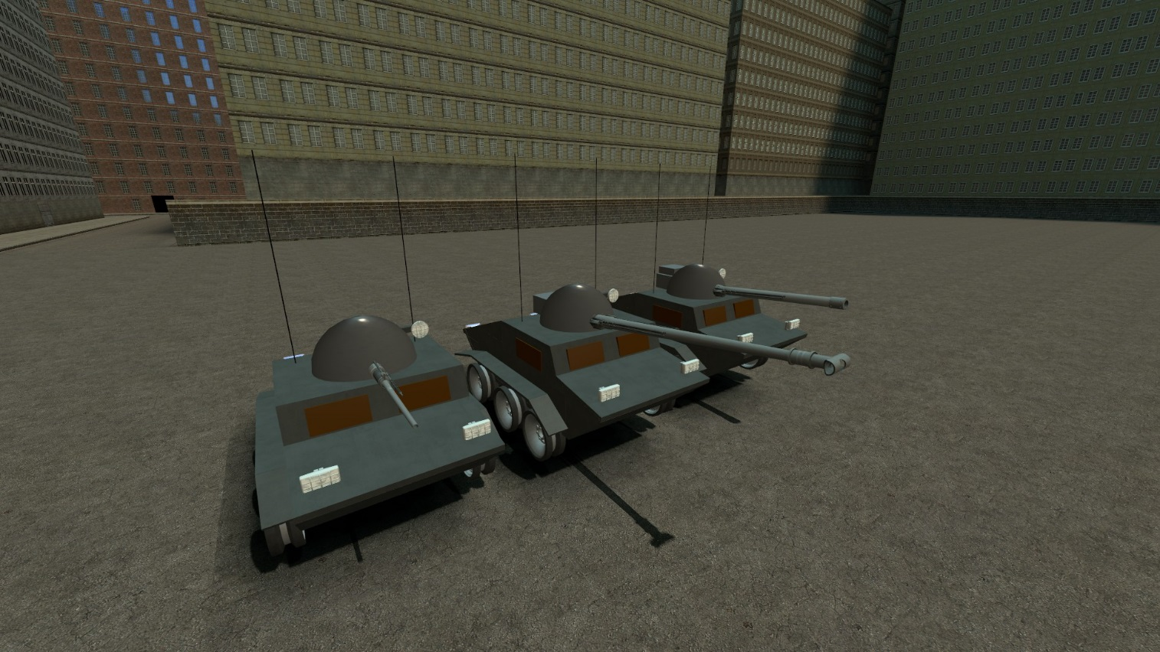

**Description:**

Fast, lightly armored and *very* unstable APC, armed with 20mm autocannon, 75mm APCR cannon and 105 HE howitzer + coaxial MG

**Controls:**

WASD for general movement

Alt – clutch

R – MG

NOTE: Nearly all ACF tanks have similar controls. Only exceptions might be R, Space and Shift and future I will only add non-standard controls to this section.

**APC Rektefire**

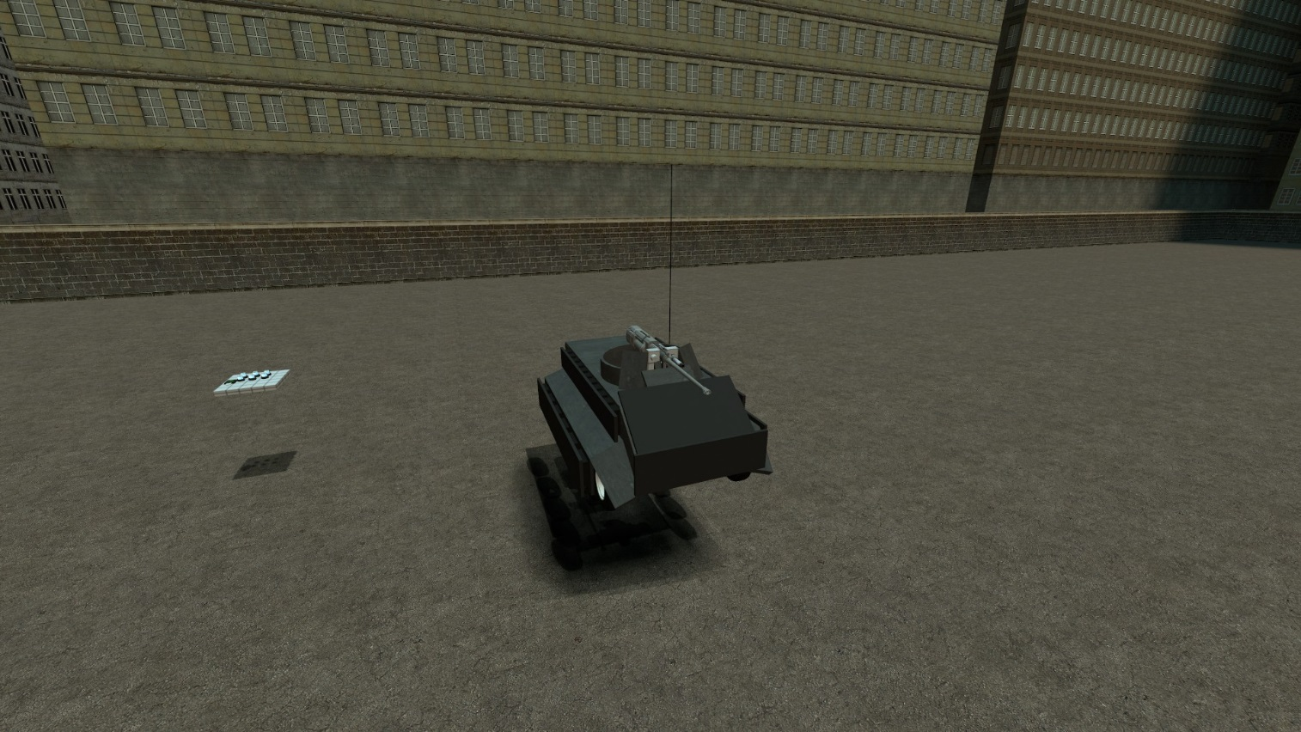

**Description:**

Light APC with bunch of reactive armor and HEAT screens. Armed with 20mm autocannon and 40mm grenade launcher. Heavy version is 1.5 tons heavier and has little bit more frontal armor and generally more stable and slow.

**Controls:**

Default for ACF tanks

**IFV**

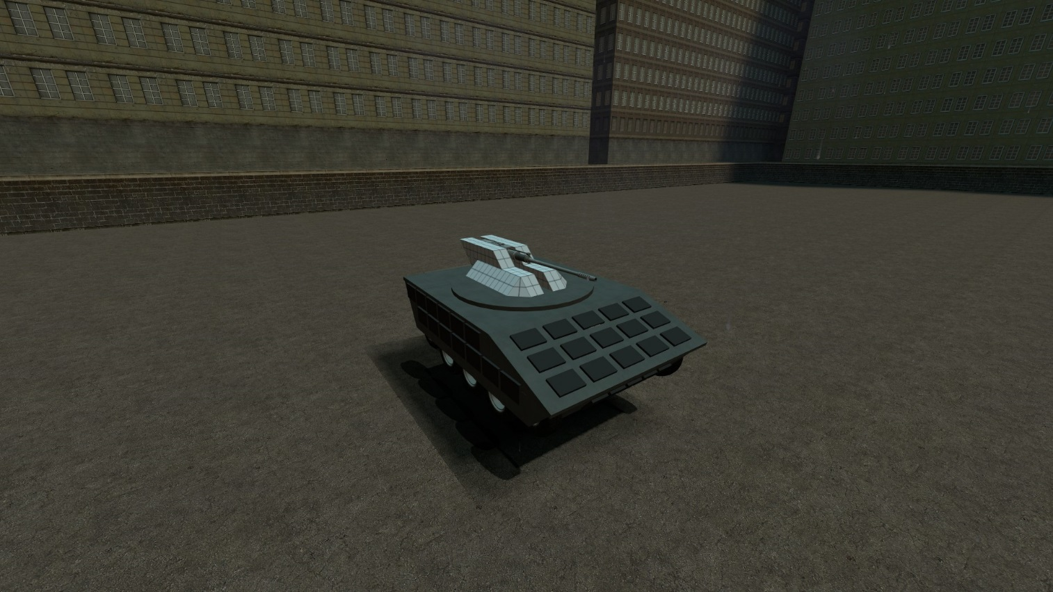

**Description:**

Heavily armored light tank killer with surprisingly good dynamics and agility. Armed with 40mm autocannon. Has 100mm sloped frontal armor and 50+50mm side armor.

**Controls:**

Default for ACF tanks

**FOCH (kind of)**

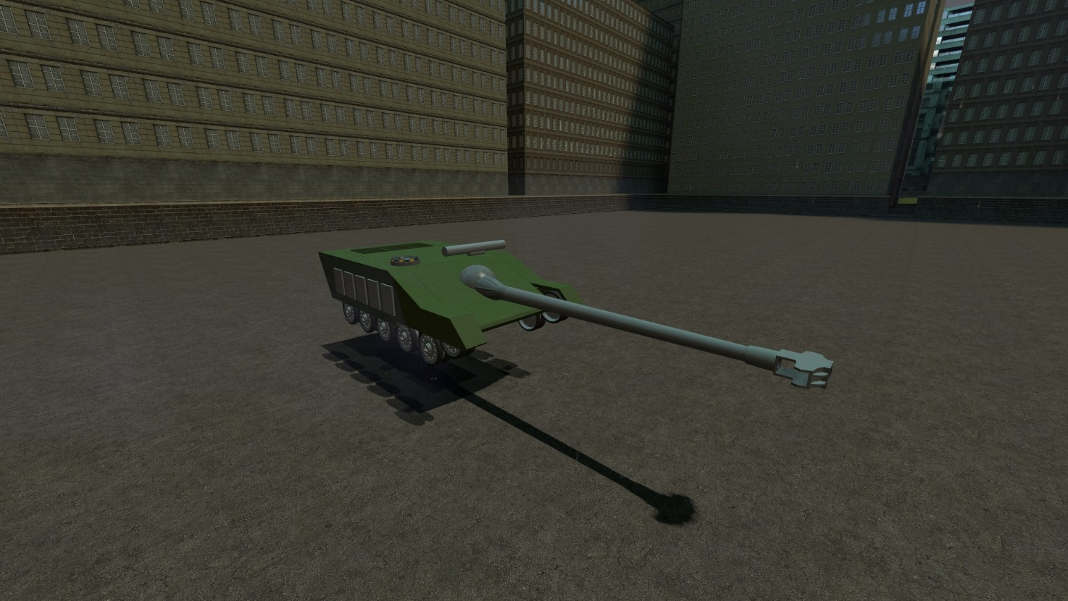

**Description:**

Inspired by World of Tanks FOCH, armed with 140mm cannon and 200mm frontal armor. Pretty agile but not very fast

**Controls:**

Default for ACF tanks

**LAV25 (It wants to be it :D)**

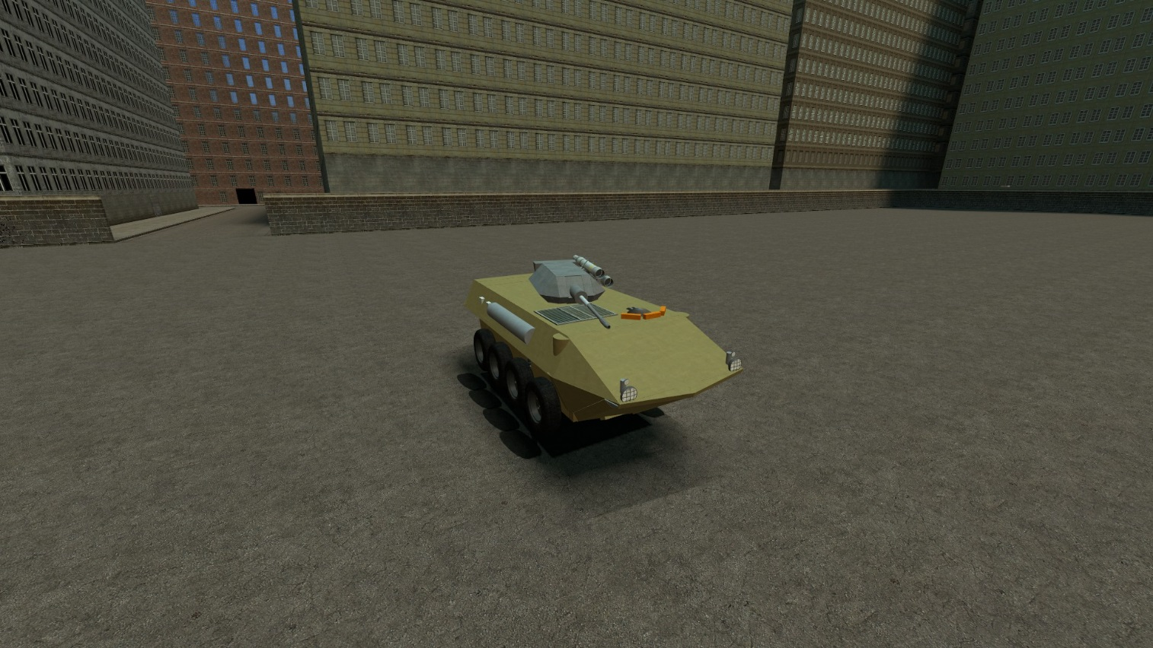

**Description:**

Super fast and agile, armed with 30mm autocannon and TOW launcher. Has 10mm armor.

**Controls:**

Default for ACF tanks +

R to reload TOW

Space to TOW

TOW flies to the crosshair position with small lag

NOTE: Controls for TOW and generally any missiles are the same for all other ACF tanks

**Leman Russ**

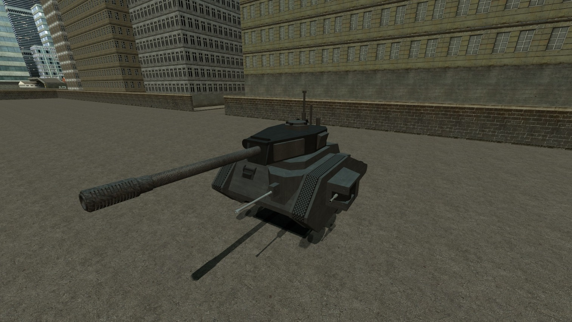

**Description:**

Named after the Primarch of the *Vlka Fenryka*, Leman Russ. 200mm frontal armor, 155 HEAT howitzer, 30mm frontal autocannon and 2 side 20mm bolters. Really good mobility for its weight

**Controls:**

Default for ACF tanks +

R to shoot central cannon

Shift to shoot side bolters

**Obj. 263**

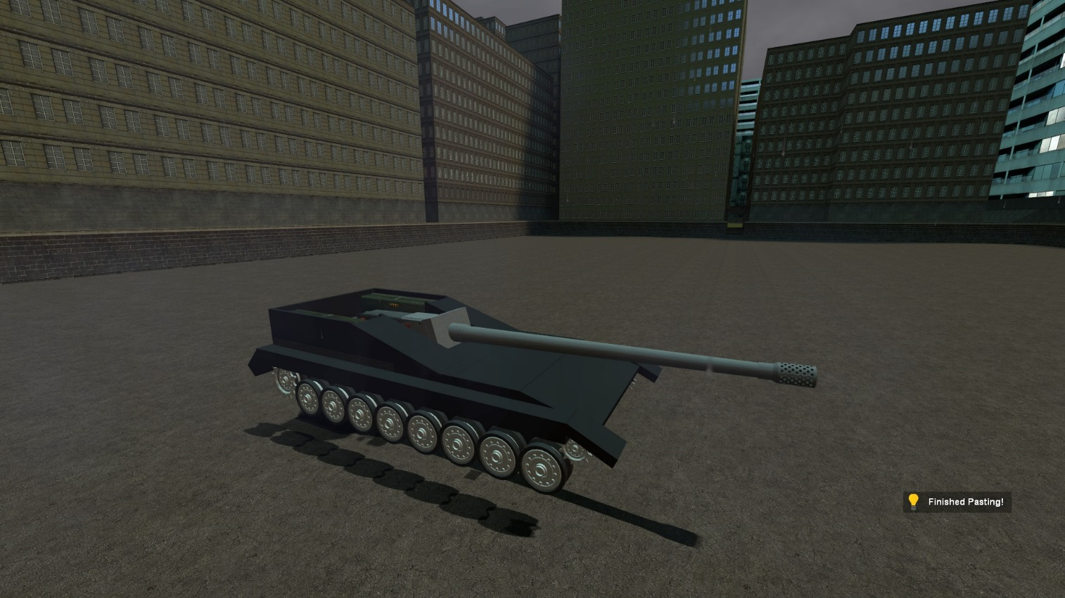

**Description:**

Tank destroyer with heavy frontal armor, 140mm cannon and good mobility

**Controls:**

Default for ACF tanks

**DA BOYZ SUPPA TANK**

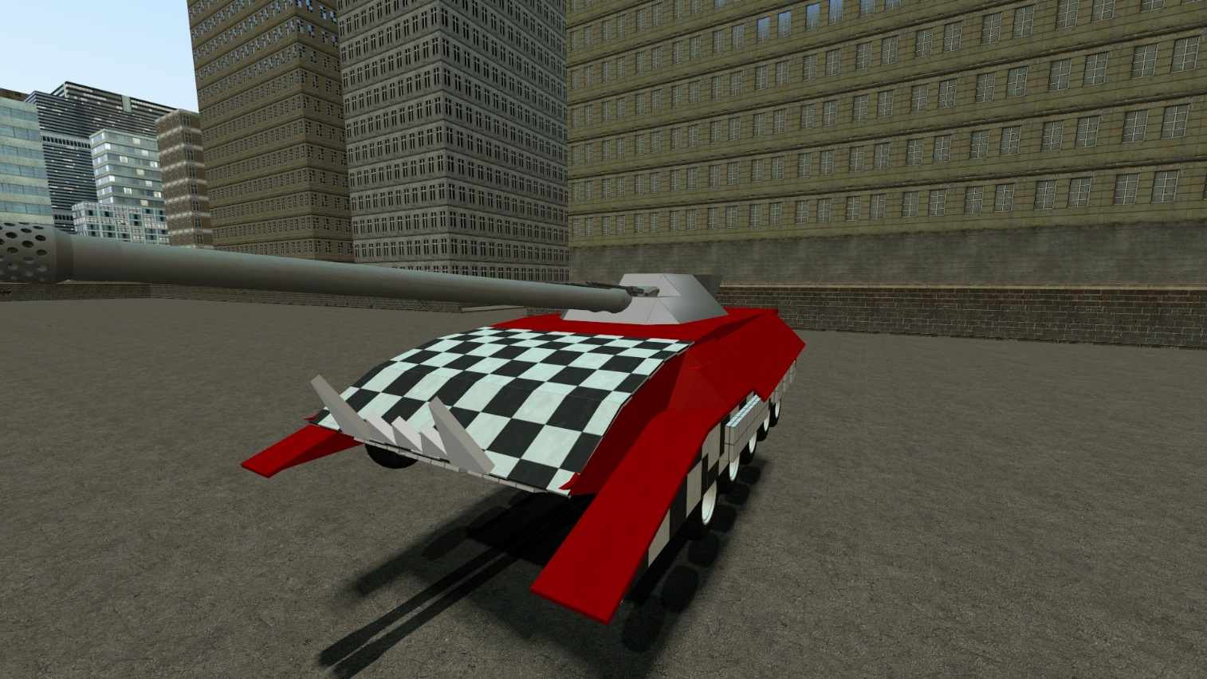

**DEZKRIPTON:**

ZOGIN TONK MADE BY BIG MEK FOR BIG BOSS! 2 BIG DETH SHOOTA AND 3 NOT THAT BIG! ENOTH DAKKA FOR BIG BOSS AND HIZ NOBZ! DA RED GOES FASTA! WWWWAAAAAAAAAAAAAAAAAAAAAAAAAAAGH

**CONTROLZ:**

WHAAAAAAAAAAAAAAAAAAAAAAAAAAAAAAAAAAAAAAAAAAAAAAAAAAAAAAAAAAAAAAAAAAAAAAAAAAAAAAAAAAAAAAAAAAAAAAAAAAAAAAAAAAAAAAAAAAAAAAAAAAAAAAAAAAAAAAAAAAAAAAAAAAAAAAAAAAAAAAAAAAAAAAAAAAAAAAAAAAAAAAAAAAAAGH

**Project Striker Series**

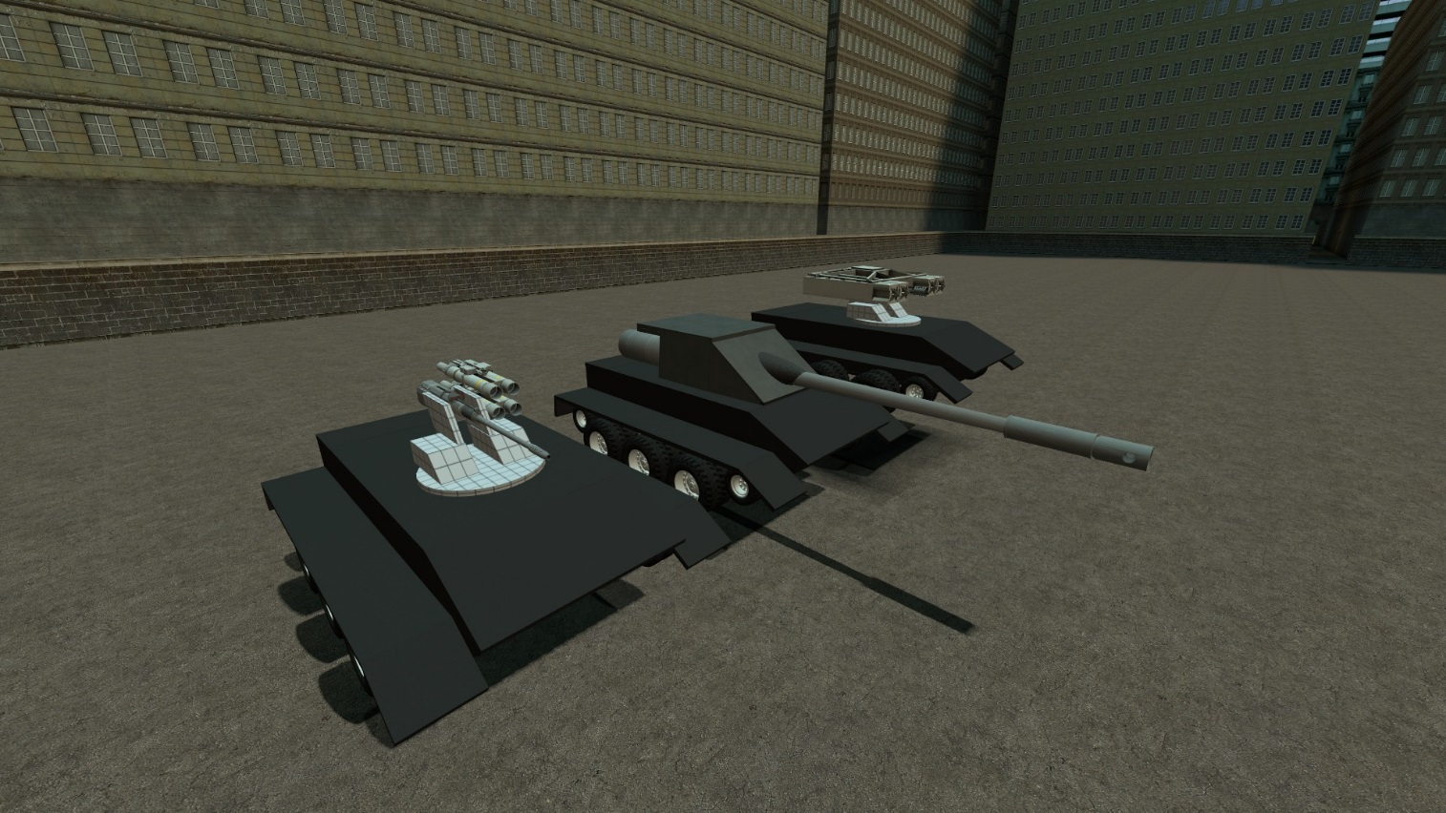

**Description:**

Series of light/medium tanks and standard chassis. Heavy and TD versions have improved armor (100mm frontal and 80 side) and decent mobility. Light and AA version have light armor (20mm frontal and 15 side) and much faster and agile.

Be advised: AA gun do not have any auto-targeting. But AA missiles do.

**Controls:**

Default for ACF tanks

**Retarded fat BMP-3**

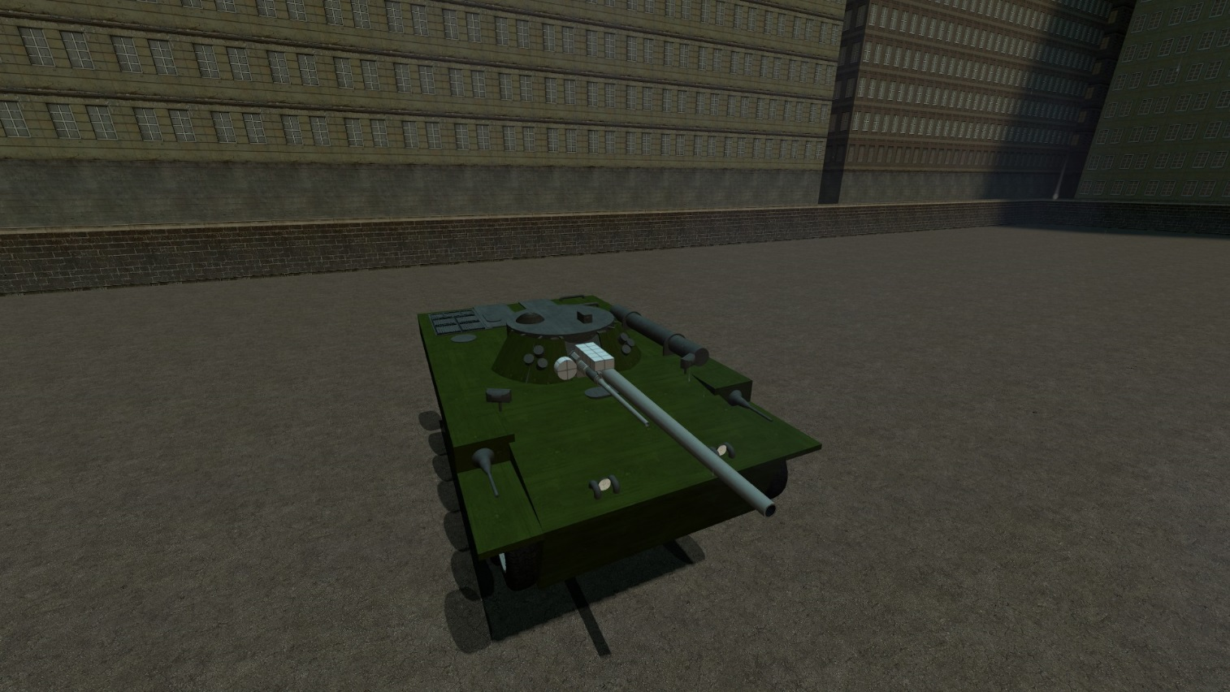

**Description:**

Fat wide armored thing. Has (for some reason) 150+150mm frontal armor, 100mm HEAT short barrel cannon and 40mm autocannon. Fast, strong and stupid.

**Controls:**

Default for ACF tanks

**Mammoth**

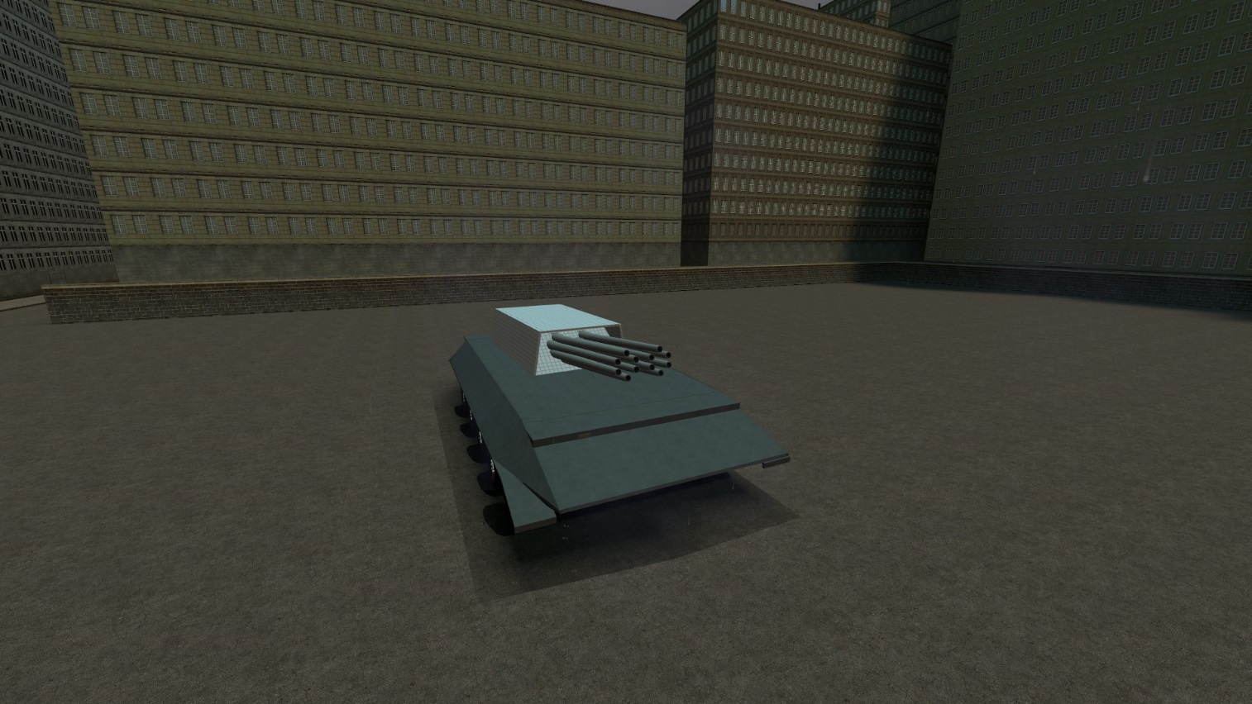

**Description:**

575 tons stupid shit that slow as fuck. Has 12 140mm sequence-fired cannons.

**Controls:**

Has 2 groups, each consists of 6 cannons. Has 1 second cooldown between each shot in 1 group. LMB to start shooting left group and RMB to start shooting right.

Rest is default for ACF tanks

**Sneaky AT**

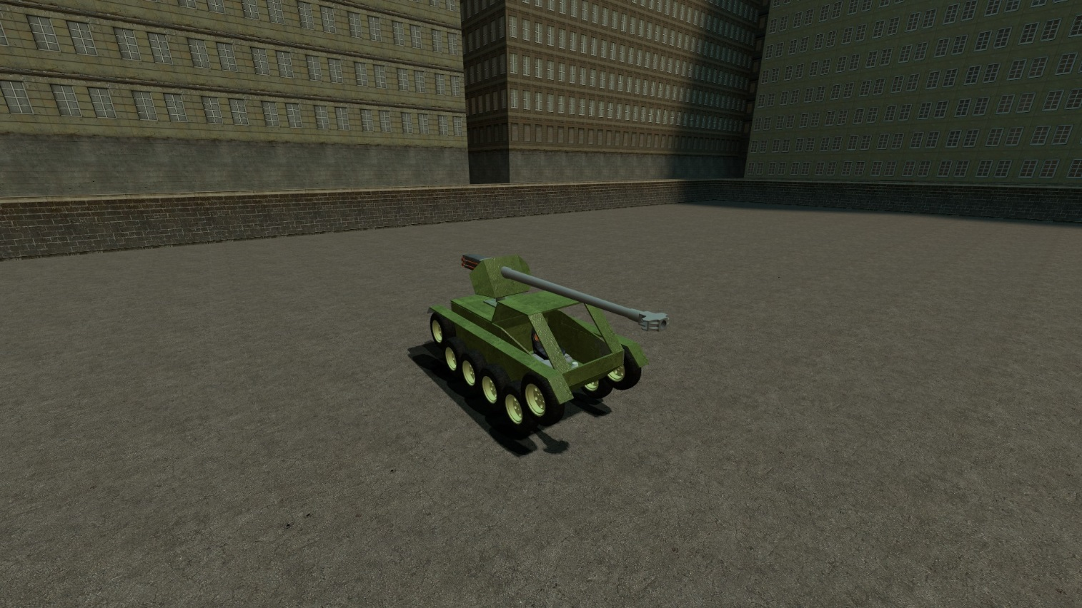

**Description:**

Small, fast unarmored gun carrier. Has 100mm APCR cannon

**Controls:**

Shift to freeze tank

Default for ACF tanks

**T-90 (It wants to be it!)**

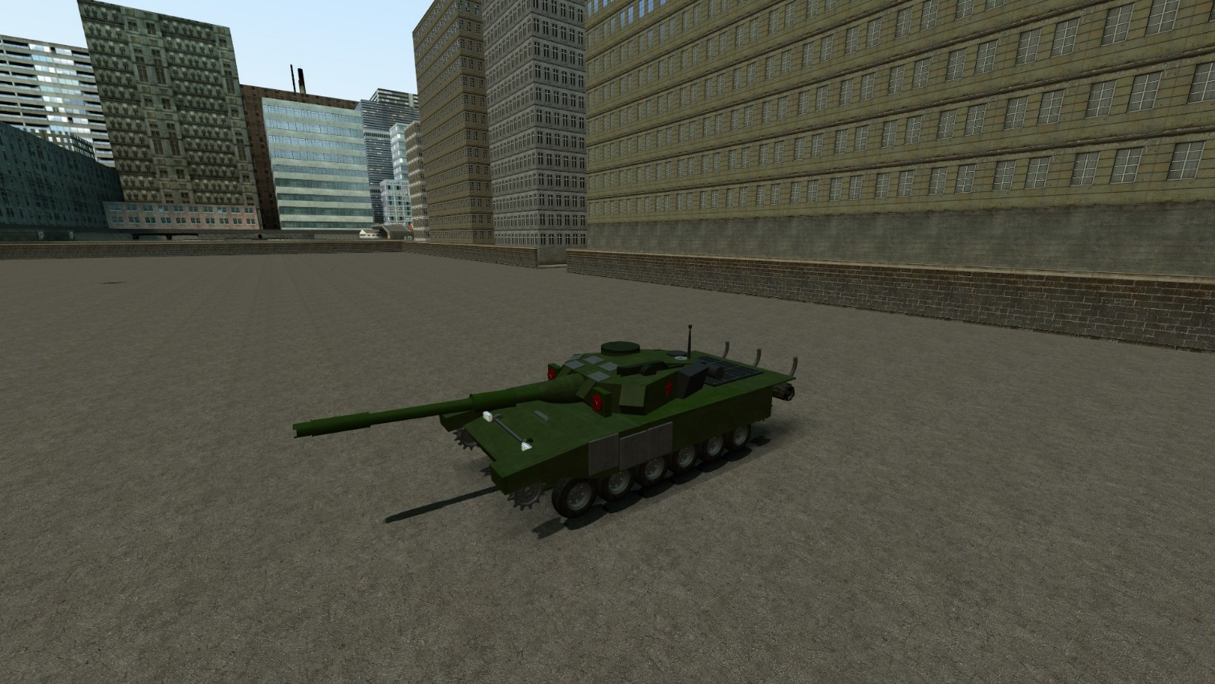

**Description:**

Great MBT with good balance between armor, mobility and weapon. Has 120mm main cannon, 120+120 frontal sloped armor and 31 hp/ton.

**Controls:**

Default for ACF tanks

**“Universal” chassis series**

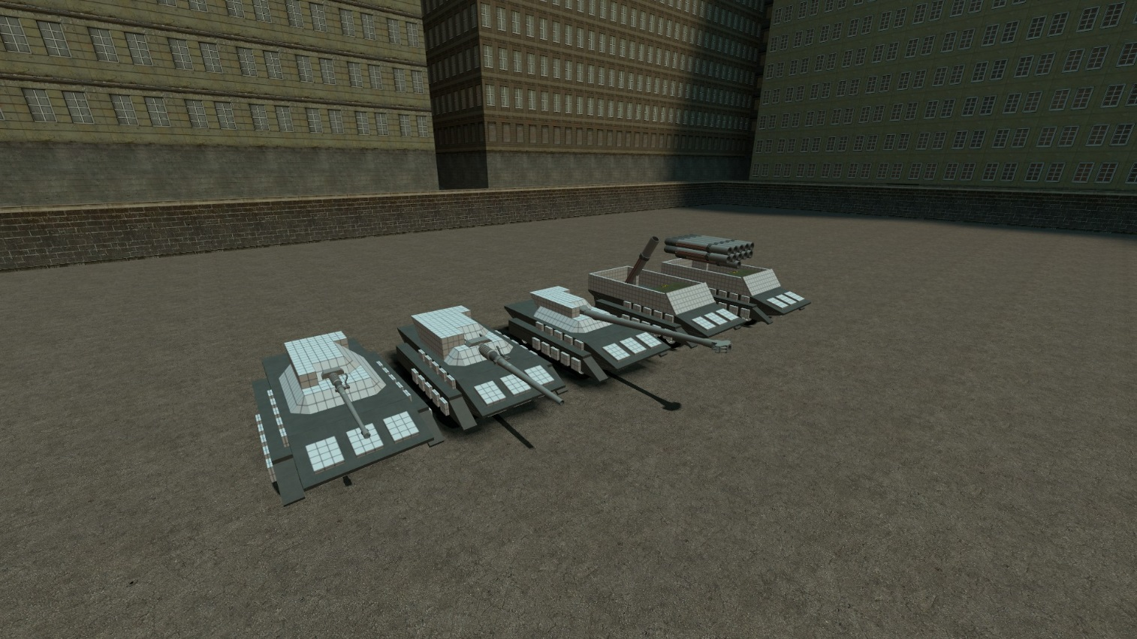

**Description:**

My 1st successful attempt to create combat-effective tank. I won’t describe each modification of it here. Be advised – it make turns *really* bad and there is no artillery computer

**Controls:**

Default for ACF tanks

**“Universal” chassis series**



**Description:**

My 1st successful attempt to create combat-effective tank. I won’t describe each modification of it here. Be advised – it make turns *really* bad and there is no artillery computer

**Controls:**

Default for ACF tanks